**RASPBERRY PI BASED VENTILATOR & HEALTH MONITORING DEVICE**

**Aim:**

During the outbreak of COVID-19, the demand for respiratory and health-care equipment has increased with each passing day. To overcome the shortage of these devices, we do not have another good solution yet that can help us achieve this requirement. We can try to design your Raspberry Pi COVID -19 Ventilator.

So, we decided to make a small respirator using the Raspberry Pi. It will also be able to monitor our health and provide information about our heart rate and SPO2 levels.

Our respirator uses a servo motor that puts pressure on the air bag (BVM bag), thus compressing the oxygen-focused air in the lungs. When the servo motor returns to its original position, it causes pressure to be released from the air bag (BVM bag), causing it to retain its original position. This helps to absorb CO2 from the lungs (similar to the process of breathing in and out). All breathing patterns should be in line with the patient's normal breathing rate. This can be achieved by changing the servo motor speed in the system. We also used the MAX30100 sensor to provide live data on the rise and fall of heart rate and oxygen levels in a patient's blood. By using the Raspberry Pi and any standard LCD display, we can detect the heart rate and blood oxygen percentage as a graph on the display screen.

**Hardware & Software Requirements:**

The design of the program is divided into two parts: Hardware and software components.

Hardware Components

A. Raspberry Pi

B. ECG sensor

C. Blood pressure sensor

D. Temperature Sensor-LM35

E. Pulse rate sensor

F Mechanical Ventilator

Software demand

A. PYTHON

B.THING SPEAK

**Project Flow:**

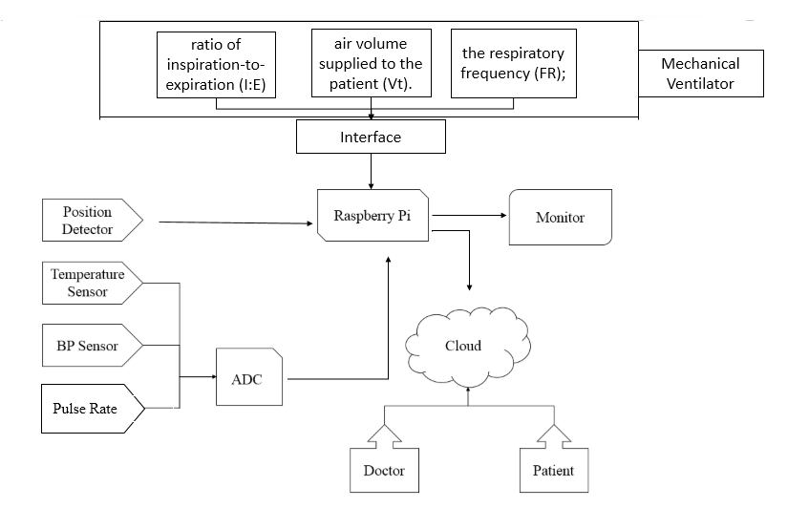

The connection between the various elements is defined using the structure of the system. Patients connect nerves to their body and the other part of the nerves are connected to the Raspberry Pi. Details sensor findings are stored in Raspberry pi 3. Data values ​​(i.e. Biometric data) are displayed on the monitoring indicator and at the same time. Saved values ​​are sent to server. All values ​​are stored on the server and the most recent value is displayed in Website. Physicians and their login details can log in and view patient data. Doctors can see all previous records of the file patient also recommends medications and changes to prescription medication. Patients are also given a personal user id and viewing password records.

**Proposed Model:**

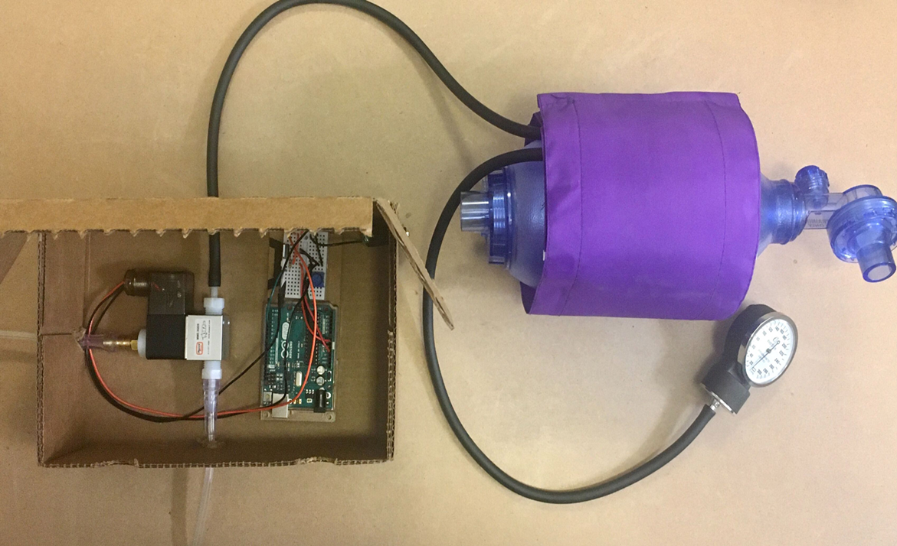

**Stake holders:**

The consumers would be the patient as this time of COVID-19 outbreak, the demand for [ventilator](https://www.electronicsforu.com/technology-trends/open-source-ventilator-projects-developed-by-experts-part-2) and health monitoring devices has increased with each passing day. And second comes the hospitals as both pvt and govt sectors are running out of beds. Then comes the industrialists who are trying to reduce the costs of the beds as much as possible in order to keep it affordable to every consumers.